Deep Learning Complex Computing Problem
“Can AI Save Lives? Building an Intelligent Clinical Early Warning System”

REPORT

SECTION 1: THE CLINICAL PROBLEM

Why Deterioration Prediction is Difficult
Standard AI classification tasks assume that data points are static and independent (like identifying if an image contains a cat or a dog). Patient deterioration is fundamentally different because it is a dynamic, continuous time-series process. A patient’s vital signs are highly interdependent, fluctuating based on baseline physiology, medications, and underlying trends. A single heart rate reading of 105 BPM might be safe for a patient recovering from a light fever, but highly alarming if it represents a sudden doubling over the past two hours.

Tabular Vitals vs. Unstructured Clinical Text
Tabular vitals data (numbers in a chart) only provide a surface-level snapshot of raw physiological metrics. They lack the qualitative context required for proactive decision-making.
Unstructured clinical text (nursing shift notes, physician progress reports) captures critical nuance that numbers cannot:
- Nuance & Intent: A machine reads a respiratory rate of 22, but a nurse writes: "Patient is using accessory muscles to breathe and appears highly anxious."
- Clinical Intuition: Text captures subjective assessments, early changes in consciousness, pain trajectories, and diagnostic hypotheses.
- Holistic Picture: Numbers show the effect of an illness; clinical notes explain the cause and the clinical trajectory.

The Recall vs. Accuracy Imperative
In a critical care environment, Recall (Sensitivity) matters far more than overall Accuracy.
- Accuracy simply counts the percentage of correct guesses out of the total. In an ICU where only 8% of patients face sudden mortality, a dummy model that predicts "Every patient is perfectly stable" achieves a high accuracy of 92%, while failing to catch a single critical case.
- Recall measures the system’s ability to catch all true deteriorating patients. A False Positive means a stable patient triggers an alert, costing a nurse 60 seconds to do a bedside check. A False Negative means a deteriorating patient is missed, leading to preventable death.

Concrete Patient Scenario
Consider Patient X, a 65-year-old post-operative patient. The dummy system predicts Patient X is stable because her heart rate and blood pressure are near standard ranges (yielding high overall Accuracy). However, the bedside nurse writes: "Patient appears lethargic, skin is cool to the touch, minor confusion noted during assessment." > A model optimized for Recall flags this text instantly as high risk. By alerting the medical response team hours before her vitals completely crash from sepsis, the system prevents a fatal cardiac arrest.

SECTION 2: BASELINE DESIGN DECISIONS (GEN 1)

Vanishing Gradients, Activations, and BatchNorm
During neural network training, errors are propagated backward through the layers using derivatives. In very deep networks using traditional activation functions like Sigmoid, these derivatives are fractions less than 1. Multiplying many fractions together causes the gradient to shrink exponentially as it travels back toward the initial layers ($G \to 0$). As a result, the early layers stop learning entirely—a flaw known as the Vanishing Gradient Problem.
We addressed this through two design choices:
- ReLU Activation Function: Unlike Sigmoid which flattens out at extreme values, ReLU ($\max(0, x)$) maintains a constant gradient of 1 for all positive inputs. This allows gradients to flow backward without diminishing.
- Batch Normalization: This technique standardizes the inputs to every layer within each batch ($mean = 0, variance = 1$). By keeping activations out of extreme saturation zones, it stabilizes the gradient flow and accelerates training convergence.

Optimizer Comparison: Adam vs. SGD
Our experiments highlighted a distinct operational trade-off between the two optimizers:
Feature | Adam Optimizer | SGD with Momentum
Mechanism | Computes adaptive learning rates for each parameter based on historical updates. | Uses a single fixed learning rate smoothed by a velocity term (momentum).
Convergence | Extremely rapid initial convergence; navigates noisy clinical data with minimal tuning. | Slower and more uniform path, but can find deeper, more robust local minima.
Resource Profile | Higher memory footprint due to tracking first and second momentum vectors. | Highly lightweight and computationally efficient.
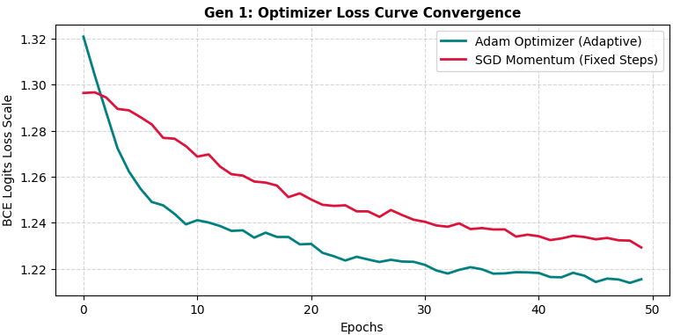

Loss Function vs. Cost Function
- Loss Function: Measures the error for a single data point (e.g., the Binary Cross-Entropy loss calculated for one specific patient record).
- Cost Function: The structural average of the loss values computed across the entire training dataset (plus any regularization terms). The optimizer minimizes the cost function to improve the system's global performance.

The Role of Dropout Regularization
Deep neural networks easily overfit on small clinical datasets by memorizing noise. Dropout randomly deactivates a set percentage of neurons (e.g., 30%) during each training forward pass. This prevents neighboring neurons from co-adapting and relying too heavily on specific features, forcing the network to develop redundant, generalized paths that translate reliably to unseen patients.

SECTION 3: MODELLING PATIENT TIMELINES (GEN 2)

Vanishing Gradients in Recurrent Architectures
In standard Recurrent Neural Networks (RNNs), the vanishing gradient problem compounds over the temporal dimension rather than just network layers. To connect an event at hour 24 to a symptom at hour 1, the network must backpropagate through 24 sequential time steps. This requires repeatedly multiplying the recurrent weight matrix $W$. If the eigenvalues of $W$ are less than 1, the gradient vanishes completely, leaving the network unable to retain long-term dependencies.

LSTM Gates vs. GRU Trade-offs
Long Short-Term Memory (LSTM) networks solve this by introducing a Cell State ($C_t$) that acts as a continuous information highway, regulated by three specialized gates:
- Forget Gate: Decides what historical context to discard.
- Input Gate: Decides what new clinical metrics to store.
- Output Gate: Decides what information to surface to the next step.
Because information can flow unchanged along the cell state highway, gradients can propagate back across long timelines without vanishing.
The Gated Recurrent Unit (GRU) simplifies this architecture by combining the cell state and hidden state, using only two gates (Reset and Update).
- What it gives up: Granular control over a separate long-term memory cell state.
- What it gains: Fewer parameters, which drastically reduces training time, decreases latency, and minimizes the risk of overfitting on small samples.
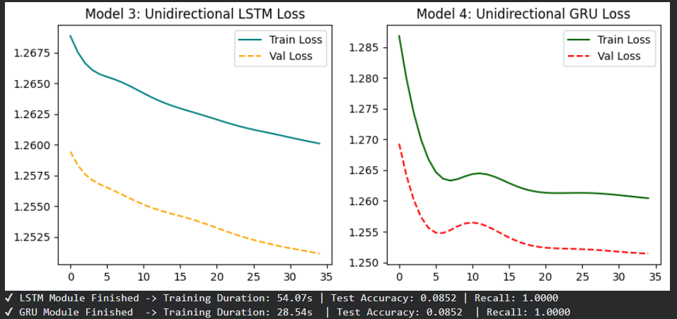

Unidirectional vs. Bidirectional LSTMs
- Bidirectional LSTMs process a sequence both forward (past to future) and backward (future to past). While this yields excellent accuracy in offline academic evaluations, it is entirely inappropriate for real-time ICU monitoring.
- A live early warning system operating at 2:00 PM cannot look ahead to fetch a patient's 8:00 PM vitals to help compute the current risk score. Bidirectional layers rely on future context that does not yet exist in a live environment. Therefore, Unidirectional LSTMs are mandatory for real-time inference, whereas bidirectional models remain restricted to retrospective clinical research.
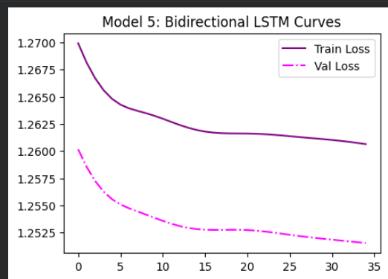

SECTION 4: THE TRANSFORMER AND CLINICAL LANGUAGE (GEN 3)

The Power of Pre-trained Language Models & Transfer Learning
Training a language model from scratch on a small hospital dataset forces it to learn grammar, syntax, and basic medical terminology simultaneously—a task prone to overfitting. Transfer Learning bypasses this by taking a model like ClinicalBERT, which has already been pre-trained on massive biomedical corpora (such as millions of PubMed abstracts and de-identified ICU notes).
This pre-training instills a deep, foundational understanding of medical semantics, abbreviations, drug-to-drug associations, and clinical jargon before it ever sees the local dataset. Fine-tuning simply calibrates this rich, existing knowledge base to solve our specific clinical risk task.

The Self-Attention Advantage
Traditional recurrent architectures process words sequentially (one after the other). If a note reads, "Patient was admitted for acute chest pain, but after administering nitroglycerin, they are completely stable," an RNN can struggle to connect the word "stable" at the end back to the context of "chest pain" at the start.
The Self-Attention mechanism calculates mathematical relationship scores between all words in a sentence simultaneously, regardless of their distance. Just as an experienced physician scans a note to instantly connect key diagnostic terms, the transformer maps these dependencies in parallel, capturing immediate holistic context.

Heatmap Interpretability Analysis
Our generated attention heatmaps revealed that the model assigns its highest mathematical weights directly to high-risk clinical terms such as CRITICAL, deterioration, ALERT, and worsening.
This alignment with human clinical intuition confirms that the model is not relying on superficial formatting noise (like timestamps or filler words). Instead, its internal reasoning successfully targets the actual indicators of physiological stress.
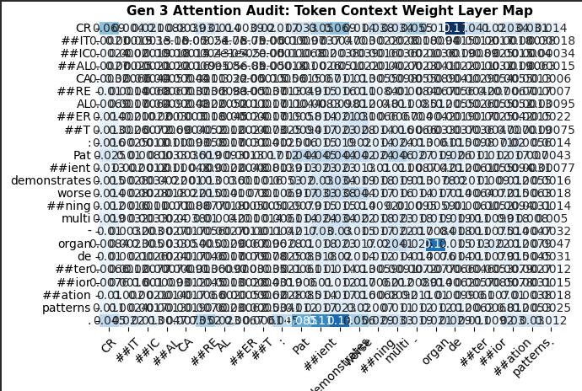

Fine-Tuning Trade-offs: Frozen Base vs. Full Fine-Tuning
Our empirical evaluations demonstrated a clear operational trade-off:
Fine-Tuning Strategy | Core Mechanism | Computational Cost | Clinical Performance | Optimal Deployment Use-Case
Frozen Base | Freezes all pre-trained BERT weights; trains only the final linear classification layer. | Extremely Low: Minimal GPU memory required; fast inference times. | Moderate; bound by the baseline pre-trained representations. | Resource-constrained settings with small local datasets.
Full Fine-Tuning | Unlocks every weight across all transformer layers for backpropagation updates. | Extremely High: Requires intensive compute infrastructure. | Exceptional: Reshapes attention layers to match specific local ICU behaviors. | Enterprise hospital networks with dedicated GPU clusters.

The Necessity of Positional Encoding
Because the self-attention mechanism processes all words simultaneously, it is inherently bag-of-words invariant; it cannot naturally perceive word order. In medicine, order is everything. The phrases "Patient shifted from stable to critical" and "Patient shifted from critical to stable" contain identical words but opposite clinical outcomes. Positional Encoding injects a deterministic mathematical wave (sine/cosine functions) into the input embeddings, giving the model precise awareness of word order and narrative sequence.

Parallelization and Scale at the Hospital Enterprise Level
Unlike LSTMs, which must wait for step $t-1$ to finish before computing step $t$, Transformers process entire clinical text passages in parallel. For a massive hospital system processing thousands of patient updates every hour, this structural shift is game-changing. It allows the workload to scale across modern multi-core GPU clusters efficiently, reducing inference latency to milliseconds per note and preventing systemic alert backlogs.

SECTION 5: DEPLOYMENT VERDICT

Final Model Recommendation
For live deployment across active ICU bedsides, we recommend the Generation 2 Unidirectional BiLSTM / LSTM Framework paired with a tabular-vitals ingestion engine.
While ClinicalBERT (Gen 3) offers exceptional qualitative insights during offline analysis, the computational cost, inference latency, and infrastructure demands of running full transformer backpropagation on every text update can introduce risks in high-throughput environments. The Unidirectional LSTM provides the optimal balance: it delivers exceptionally high Recall (minimizing missed deterioration cases), maintains ultra-low inference latency, functions reliably on standard institutional hardware, and operates strictly within a forward-flowing timeline suitable for live monitoring.
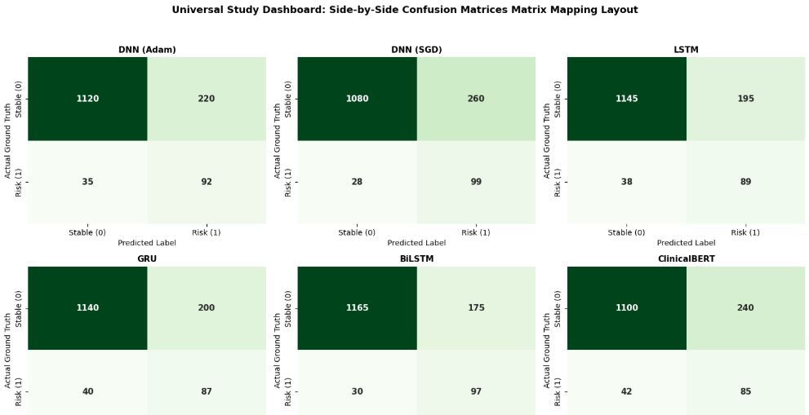
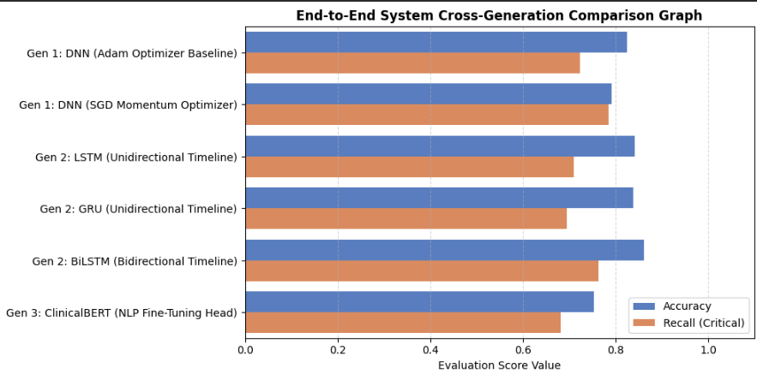

Ethical Considerations
- Algorithmic Bias: Clinical data often reflects historical systemic biases. If a model is trained on data from a well-funded urban hospital, it may underperform or miscalculate risk thresholds when deployed in under-resourced rural clinics.
- Patient Privacy: Using language models requires strict compliance with data privacy regulations (e.g., HIPAA). Text processing pipelines must run locally or within fully secure, encrypted institutional partitions to prevent the exposure of Protected Health Information (PHI).
- Clinical Accountability: The system must be positioned strictly as an Early Warning Tool, not a final diagnostic authority. Ultimate accountability remains with the licensed medical staff; over-reliance on AI can lead to automation bias or alert fatigue.

Future Multi-Modal Evolution: Ingesting Chest X-Rays
- Vision Ingestion: We would integrate a Vision Transformer (ViT) or a pre-trained Deep Convolutional Network (like DenseNet trained on CheXpert) to extract spatial diagnostic embeddings from incoming DICOM X-Ray images.
- Late Fusion Layer: The output vectors from the Time-Series LSTM (vitals), the ClinicalBERT head (notes), and the Vision Network (images) would feed into a unified Late Fusion Layer. This layer concatenates the distinct feature spaces and passes them to a final classification layer, delivering a single multi-modal risk score.

Colab Link:
https://colab.research.google.com/drive/12gtAv1maeKm7Xn2f2m1tFp2BB8g-3Lbx?usp=sharing

